**Lab#3 Design**

**web pages for mobile shopping application**

**1. Home Page**

**Final outcome:**

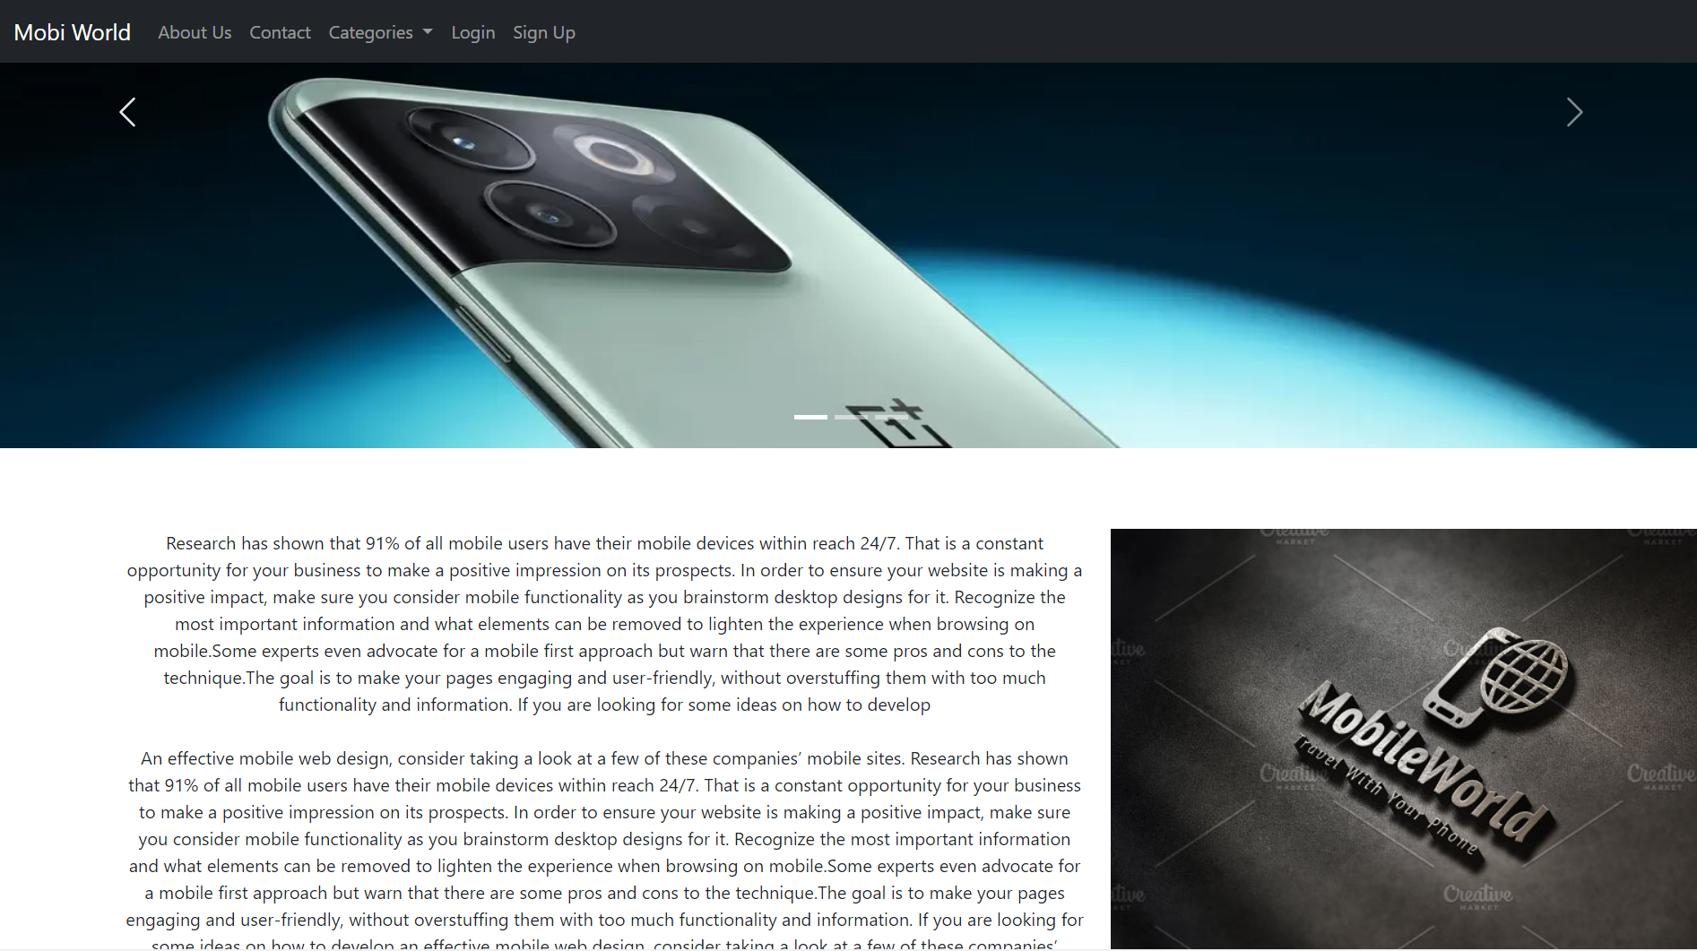

**Code Snippet:**

<!doctype html>

<html lang="en">

<head>

<meta charset="utf-8">

<meta name="viewport" content="width=device-width, initial-scale=1">

<title>Home :: Mobiworld</title>

<link href="https://cdn.jsdelivr.net/npm/bootstrap@5.2.0/dist/css/bootstrap.min.css" rel="stylesheet" integrity="sha384-gH2yIJqKdNHPEq0n4Mqa/HGKIhSkIHeL5AyhkYV8i59U5AR6csBvApHHNl/vI1Bx" crossorigin="anonymous">

</head>

<body>

<!--nav bar-->

<nav class="navbar navbar-expand-lg fixed-top navbar-dark bg-dark">

<div class="container-fluid">

<a class="navbar-brand" href="index.html">Mobi World</a>

<button class="navbar-toggler" type="button" data-bs-toggle="collapse" data-bs-target="#navbarNavAltMarkup" aria-controls="navbarNavAltMarkup" aria-expanded="false" aria-label="Toggle navigation">

<span class="navbar-toggler-icon"></span>

</button>

<div class="collapse navbar-collapse" id="navbarNavAltMarkup">

<div class="navbar-nav">

<a class="nav-link" href="#">About Us</a>

<a class="nav-link" href="#">Contact</a>

<li class="nav-item dropdown">

<a class="nav-link dropdown-toggle" href="categories.html" role="button" data-bs-toggle="dropdown" aria-expanded="false">

Categories

</a>

<ul class="dropdown-menu">

<li><a class="dropdown-item" href="categories.html">Oppo</a></li>

<li><a class="dropdown-item" href="categories.html">Vivo</a></li>

<li><a class="dropdown-item" href="categories.html">Samsung</a></li>

<li><a class="dropdown-item" href="categories.html">Iphone</a></li>

</ul>

</li>

<a class="nav-link" href="login.html">Login</a>

<a class="nav-link" href="signup.html">Sign Up</a>

</div>

</div>

</div>

</nav>

<div id="carouselExampleIndicators" class="carousel slide" data-bs-ride="true">

<div class="carousel-indicators">

<button type="button" data-bs-target="#carouselExampleIndicators" data-bs-slide-to="0" class="active" aria-current="true" aria-label="Slide 1"></button>

<button type="button" data-bs-target="#carouselExampleIndicators" data-bs-slide-to="1" aria-label="Slide 2"></button>

<button type="button" data-bs-target="#carouselExampleIndicators" data-bs-slide-to="2" aria-label="Slide 3"></button>

</div>

<div class="carousel-inner">

<div class="carousel-item active">

<img src="img/OnePlus-10T-feat.webp" height="600" class="d-block w-100" alt="...">

</div>

<div class="carousel-item">

<img src="..." class="d-block w-100" alt="...">

</div>

<div class="carousel-item">

<img src="..." class="d-block w-100" alt="...">

</div>

</div>

<button class="carousel-control-prev" type="button" data-bs-target="#carouselExampleIndicators" data-bs-slide="prev">

<span class="carousel-control-prev-icon" aria-hidden="true"></span>

<span class="visually-hidden">Previous</span>

</button>

<button class="carousel-control-next" type="button" data-bs-target="#carouselExampleIndicators" data-bs-slide="next">

<span class="carousel-control-next-icon" aria-hidden="true"></span>

<span class="visually-hidden">Next</span>

</button>

</div>

<div class="container text-center">

<div class="row">

<div class="col-sm-8"> Research has shown that 91% of all mobile users have their mobile devices within reach 24/7. That is a constant opportunity for your business to make a positive impression on its prospects. In order to ensure your website is making a positive impact, make sure you consider mobile functionality as you brainstorm desktop designs for it. Recognize the most important information and what elements can be removed to lighten the experience when browsing on mobile.Some experts even advocate for a mobile first approach but warn that there are some pros and cons to the technique.The goal is to make your pages engaging and user-friendly, without overstuffing them with too much functionality and information.

If you are looking for some ideas on how to develop <br> <br> An effective mobile web design, consider taking a look at a few of these companies’ mobile sites. Research has shown that 91% of all mobile users have their mobile devices within reach 24/7. That is a constant opportunity for your business to make a positive impression on its prospects.

In order to ensure your website is making a positive impact, make sure you consider mobile functionality as you brainstorm desktop designs for it. Recognize the most important information and what elements can be removed to lighten the experience when browsing on mobile.Some experts even advocate for a mobile first approach but warn that there are some pros and cons to the technique.The goal is to make your pages engaging and user-friendly, without overstuffing them with too much functionality and information.

If you are looking for some ideas on how to develop an effective mobile web design, consider taking a look at a few of these companies’ mobile sites.</div>

<div class="col-sm-4"><img src="img/mobiworld.jpg" alt=""></div> </div>

<script src="https://cdn.jsdelivr.net/npm/bootstrap@5.2.0/dist/js/bootstrap.bundle.min.js" integrity="sha384A3rJD856KowSb7dwlZdYEkO39Gagi7vIsF0jrRAoQmDKKtQBHUuLZ9AsSv4jD4Xa" crossorigin="anonymous"></script>

</body>

</html>

**2. Categories page:**

**Final outcome:**

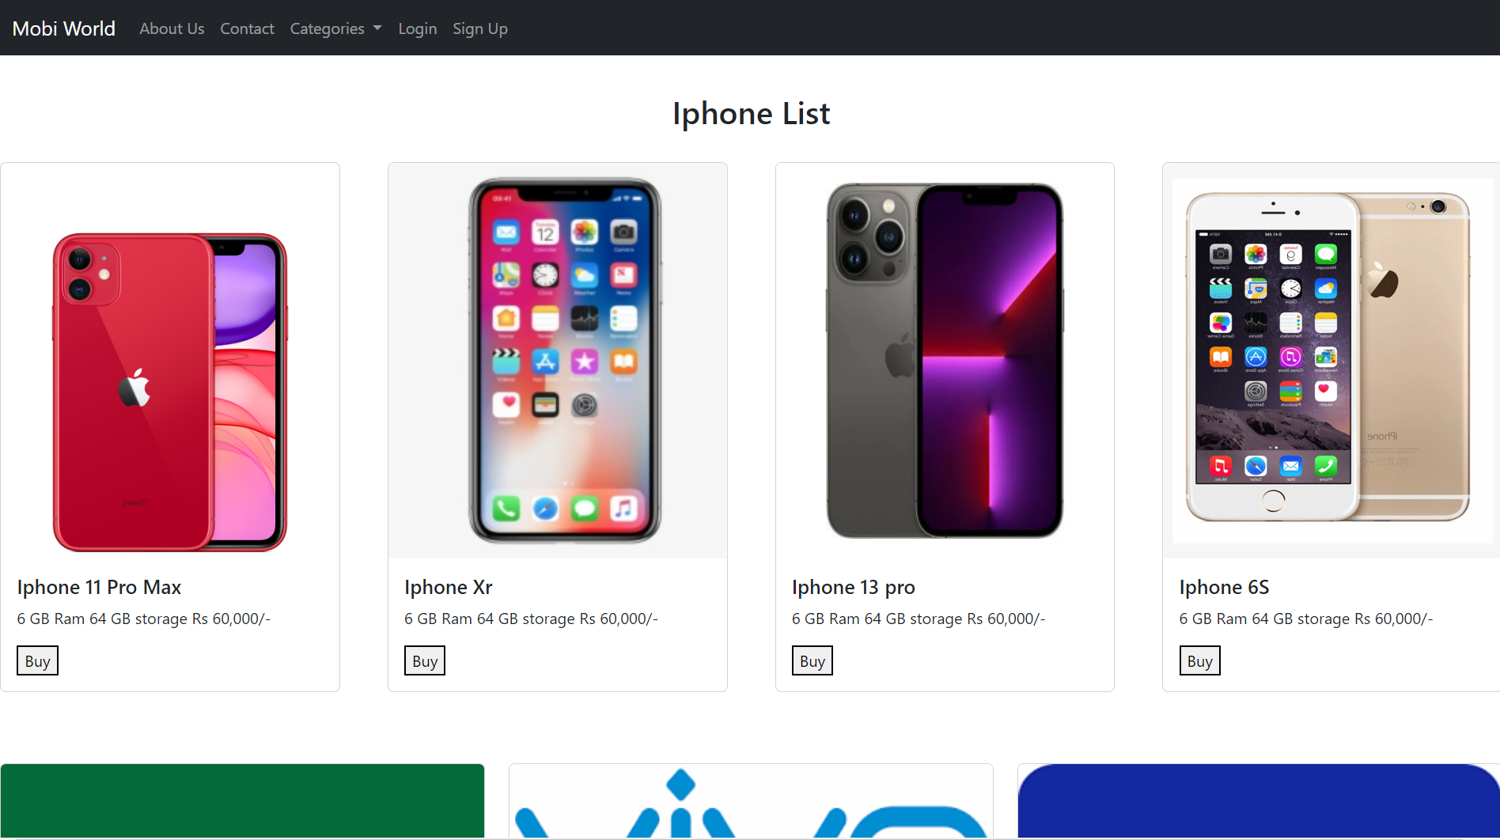

**Code snippet:**

<!doctype html>

<html lang="en">

<head>

<meta charset="utf-8">

<meta name="viewport" content="width=device-width, initial-scale=1">

<title>Home :: Mobiworld</title>

<link href="https://cdn.jsdelivr.net/npm/bootstrap@5.2.0/dist/css/bootstrap.min.css" rel="stylesheet" integrity="sha384-gH2yIJqKdNHPEq0n4Mqa/HGKIhSkIHeL5AyhkYV8i59U5AR6csBvApHHNl/vI1Bx" crossorigin="anonymous">

</head>

<body>

<!--nav bar-->

<nav class="navbar navbar-expand-lg fixed-top navbar-dark bg-dark">

<div class="container-fluid">

<a class="navbar-brand" href="index.html">Mobi World</a>

<button class="navbar-toggler" type="button" data-bs-toggle="collapse" data-bs-target="#navbarNavAltMarkup" aria-controls="navbarNavAltMarkup" aria-expanded="false" aria-label="Toggle navigation">

<span class="navbar-toggler-icon"></span>

</button>

<div class="collapse navbar-collapse" id="navbarNavAltMarkup">

<div class="navbar-nav">

<a class="nav-link" href="#">About Us</a>

<a class="nav-link" href="#">Contact</a>

<li class="nav-item dropdown">

<a class="nav-link dropdown-toggle" href="#" role="button" data-bs-toggle="dropdown" aria-expanded="false"> Categories </a>

<ul class="dropdown-menu">

<li><a class="dropdown-item" href="#">Oppo</a></li>

<li><a class="dropdown-item" href="#">Vivo</a></li>

<li><a class="dropdown-item" href="#">Samsung</a></li>

<li><a class="dropdown-item" href="#">Iphone</a></li>

</ul>

</li>

<a class="nav-link" href="login.html">Login</a>

<a class="nav-link" href="signup.html">Sign Up</a>

</div> </div> </div> </nav>

<br><br><br><br>

<div class="row row-cols-1 row-cols-md-3 g-4">

<div class="col">

<div class="card">

<img src="img/oppo.png" height="250" class="card-img-top " alt="...">

<div class="card-body">

<h5 class="card-title text-center">Oppo Phones</h5>

<p class="card-text">Explore the latest innovative OPPO smartphones and accessories and leap into the future with OPPO Reno7 Series, OPPO Find X5 Series and OPPO Enco Air2.</p>

</div>

</div>

</div>

<div class="col">

<div class="card">

<img src="img/vivo.png" height="250" class="card-img-top" alt="...">

<div class="card-body">

<h5 class="card-title text-center">Vivo Phone</h5>

<p class="card-text">vivo and ZEISS Enter Global Partnership for Mobile Imaging. Brand News. vivo Joins UEFA to Present the EURO 2020 Closing Ceremony. Video. V23 Series.</p>

</div>

</div>

</div>

<div class="col">

<div class="card">

<img src="img/samsung.png" height="250" class="card-img-top" alt="...">

<div class="card-body">

<h5 class="card-title text-center">Samsung Phone</h5>

<p class="card-text">Simple, iconic, timeless · Our logo is composed of our English brand name, “Samsung.”, The lettermark, Lettermark colors · Samsung Blue · Black.</p>

</div>

</div>

</div>

<div class="col">

<div class="card">

<img src="img/iphone.jpg" height="250" class="card-img-top" alt="...">

<div class="card-body">

<h5 class="card-title text-center">Iphone Phone</h5>

<p class="card-text">This Unicode character has no emoji version, meaning this is intended to display only as a black and white glyph on most platforms</p>

</div>

</div>

</div>

<div class="col">

<div class="card">

<img src="img/micromax.png" height="250" class="card-img-top" alt="...">

<div class="card-body">

<h5 class="card-title text-center">Micromax Phone</h5>

<p class="card-text">Micromax is democratising technology by giving you access to the best features at INforIndia pricing. Explore and Buy IN mobiles smartphone by Micromax.</p>

</div>

</div>

</div>

<div class="col">

<div class="card">

<img src="img/realme.png" height="250" class="card-img-top" alt="...">

<div class="card-body">

<h5 class="card-title text-center">Realme Phone</h5>

<p class="card-text">Take a leap into realme online store. Buy everything right from realme smartphones to smart TV, wearables, audios and smart home products.</p>

</div>

</div>

</div>

<script src="https://cdn.jsdelivr.net/npm/bootstrap@5.2.0/dist/js/bootstrap.bundle.min.js" integrity="sha384-A3rJD856KowSb7dwlZdYEkO39Gagi7vIsF0jrRAoQmDKKtQBHUuLZ9AsSv4jD4Xa" crossorigin="anonymous"></script>

</body>

</html>

**3. User registration web page**

**Final outcome:**

**Code Snippet:**

<!doctype html>

<html lang="en">

<head>

<meta charset="utf-8">

<meta name="viewport" content="width=device-width, initial-scale=1">

<title>Login :: Mobiworld</title>

<link href="https://cdn.jsdelivr.net/npm/bootstrap@5.2.0/dist/css/bootstrap.min.css" rel="stylesheet" integrity="sha384-gH2yIJqKdNHPEq0n4Mqa/HGKIhSkIHeL5AyhkYV8i59U5AR6csBvApHHNl/vI1Bx" crossorigin="anonymous">

</head>

<body>

<!--nav bar-->

<nav class="navbar navbar-expand-lg fixed-top navbar-dark bg-dark">

<div class="container-fluid">

<a class="navbar-brand" href="index.html">Mobi World</a>

<button class="navbar-toggler" type="button" data-bs-toggle="collapse" data-bs-target="#navbarNavAltMarkup" aria-controls="navbarNavAltMarkup" aria-expanded="false" aria-label="Toggle navigation">

<span class="navbar-toggler-icon"></span>

</button>

<div class="collapse navbar-collapse" id="navbarNavAltMarkup">

<div class="navbar-nav">

<a class="nav-link" href="#">About Us</a>

<a class="nav-link" href="#">Contact</a>

<li class="nav-item dropdown">

<a class="nav-link dropdown-toggle" href="#" role="button" data-bs-toggle="dropdown" aria-expanded="false">

Categories

</a>

<ul class="dropdown-menu">

<li><a class="dropdown-item" href="#">Oppo</a></li>

<li><a class="dropdown-item" href="#">Vivo</a></li>

<li><a class="dropdown-item" href="#">Samsung</a></li>

<li><a class="dropdown-item" href="#">Iphone</a></li>

</ul>

</li>

<a class="nav-link" href="#">Login</a>

<a class="nav-link" href="#">Sign Up</a>

</div>

</div>

</div>

</nav>

<!--Login -->

<br><br>

<div class="container text-center">

<div class="row">

<div class="col align-self-center ">

<form action="" method="post" >

<br> <br> <br>

<h1 class="center">Mobi World User registration</h1>

<br> <br> <br>

<div class="input-group input-group-lg">

<span class="input-group-text" id="inputGroup-sizing-lg">Name :</span>

<input type="text" class="form-control" aria-label="Sizing example input" aria-describedby="inputGroup-sizing-lg">

</div>

<br>

<div class="input-group input-group-lg">

<span class="input-group-text" id="inputGroup-sizing-lg">Email :</span>

<input type="text" class="form-control" aria-label="Sizing example input" aria-describedby="inputGroup-sizing-lg">

</div>

<br>

<div class="input-group input-group-lg">

<span class="input-group-text" id="inputGroup-sizing-lg">Password :</span>

<input type="text" class="form-control" aria-label="Sizing example input" aria-describedby="inputGroup-sizing-lg">

</div>

<br>

<div class="input-group input-group-lg">

<span class="input-group-text" id="inputGroup-sizing-lg">Re-Password :</span>

<input type="text" class="form-control" aria-label="Sizing example input" aria-describedby="inputGroup-sizing-lg">

</div>

<div class="d-grid gap-2">

<br> <br>

<button type="button" class="btn btn-success">Register</button>

</div>

</form>

</div>

</div>

</div>

<script src="https://cdn.jsdelivr.net/npm/bootstrap@5.2.0/dist/js/bootstrap.bundle.min.js" integrity="sha384-A3rJD856KowSb7dwlZdYEkO39Gagi7vIsF0jrRAoQmDKKtQBHUuLZ9AsSv4jD4Xa" crossorigin="anonymous"></script>

</body>

</html>

**4. Login page for User**

**Final Outcome:**

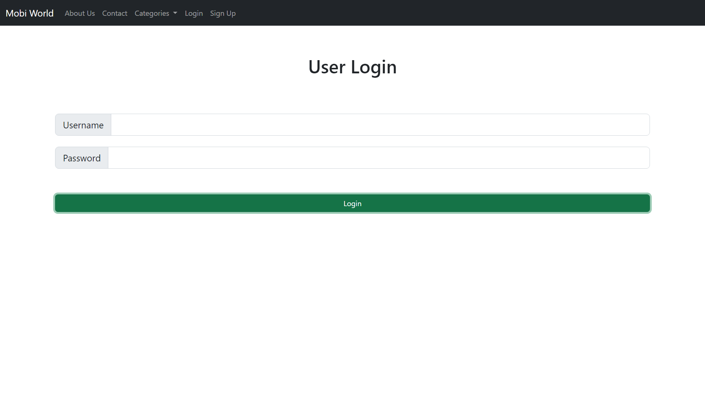

**Code Snippet:**

<!doctype html>

<html lang="en">

<head>

<meta charset="utf-8">

<meta name="viewport" content="width=device-width, initial-scale=1">

<title>Login :: Mobiworld</title>

<link href="https://cdn.jsdelivr.net/npm/bootstrap@5.2.0/dist/css/bootstrap.min.css" rel="stylesheet" integrity="sha384-gH2yIJqKdNHPEq0n4Mqa/HGKIhSkIHeL5AyhkYV8i59U5AR6csBvApHHNl/vI1Bx" crossorigin="anonymous">

</head>

<body>

<!--nav bar-->

<nav class="navbar navbar-expand-lg fixed-top navbar-dark bg-dark">

<div class="container-fluid">

<a class="navbar-brand" href="index.html">Mobi World</a>

<button class="navbar-toggler" type="button" data-bs-toggle="collapse" data-bs-target="#navbarNavAltMarkup" aria-controls="navbarNavAltMarkup" aria-expanded="false" aria-label="Toggle navigation">

<span class="navbar-toggler-icon"></span>

</button>

<div class="collapse navbar-collapse" id="navbarNavAltMarkup">

<div class="navbar-nav">

<a class="nav-link" href="#">About Us</a>

<a class="nav-link" href="#">Contact</a>

<li class="nav-item dropdown">

<a class="nav-link dropdown-toggle" href="#" role="button" data-bs-toggle="dropdown" aria-expanded="false">

Categories

</a>

<ul class="dropdown-menu">

<li><a class="dropdown-item" href="#">Oppo</a></li>

<li><a class="dropdown-item" href="#">Vivo</a></li>

<li><a class="dropdown-item" href="#">Samsung</a></li>

<li><a class="dropdown-item" href="#">Iphone</a></li>

</ul>

</li>

<a class="nav-link" href="#">Login</a>

<a class="nav-link" href="#">Sign Up</a>

</div>

</div>

</div>

</nav>

<!--Login -->

<br><br>

<div class="container text-center">

<div class="row">

<div class="col align-self-center ">

<form action="" method="post" >

<br> <br> <br>

<h1 class="center">User Login </h1>

<br> <br> <br>

<div class="input-group input-group-lg">

<span class="input-group-text" id="inputGroup-sizing-lg">Username</span>

<input type="text" class="form-control" aria-label="Sizing example input" aria-describedby="inputGroup-sizing-lg">

</div>

<br>

<div class="input-group input-group-lg">

<span class="input-group-text" id="inputGroup-sizing-lg">Password</span>

<input type="text" class="form-control" aria-label="Sizing example input" aria-describedby="inputGroup-sizing-lg">

</div>

<div class="d-grid gap-2">

<br> <br>

<button type="button" class="btn btn-success">Login</button>

</div>

</form>

</div>

</div>

</div>

<script src="https://cdn.jsdelivr.net/npm/bootstrap@5.2.0/dist/js/bootstrap.bundle.min.js" integrity="sha384-A3rJD856KowSb7dwlZdYEkO39Gagi7vIsF0jrRAoQmDKKtQBHUuLZ9AsSv4jD4Xa" crossorigin="anonymous"></script>

</body>

</html>

**5. Detailed product page**

**Final outcome:**

**Code Snippet:**

<!doctype html>

<html lang="en">

<head>

<meta charset="utf-8">

<meta name="viewport" content="width=device-width, initial-scale=1">

<title>Home :: Mobiworld</title>

<link href="https://cdn.jsdelivr.net/npm/bootstrap@5.2.0/dist/css/bootstrap.min.css" rel="stylesheet" integrity="sha384-gH2yIJqKdNHPEq0n4Mqa/HGKIhSkIHeL5AyhkYV8i59U5AR6csBvApHHNl/vI1Bx" crossorigin="anonymous">

</head>

<body>

<!--nav bar-->

<nav class="navbar navbar-expand-lg fixed-top navbar-dark bg-dark">

<div class="container-fluid">

<a class="navbar-brand" href="index.html">Mobi World</a>

<button class="navbar-toggler" type="button" data-bs-toggle="collapse" data-bs-target="#navbarNavAltMarkup" aria-controls="navbarNavAltMarkup" aria-expanded="false" aria-label="Toggle navigation">

<span class="navbar-toggler-icon"></span>

</button>

<div class="collapse navbar-collapse" id="navbarNavAltMarkup">

<div class="navbar-nav">

<a class="nav-link" href="#">About Us</a>

<a class="nav-link" href="#">Contact</a>

<li class="nav-item dropdown">

<a class="nav-link dropdown-toggle" href="categories.html" role="button" data-bs-toggle="dropdown" aria-expanded="false">

Categories

</a>

<ul class="dropdown-menu">

<li><a class="dropdown-item" href="categories.html">Oppo</a></li>

<li><a class="dropdown-item" href="categories.html">Vivo</a></li>

<li><a class="dropdown-item" href="categories.html">Samsung</a></li>

<li><a class="dropdown-item" href="categories.html">Iphone</a></li>

</ul>

</li>

<a class="nav-link" href="login.html">Login</a>

<a class="nav-link" href="signup.html">Sign Up</a>

</div>

</div>

</div>

</nav>

<br> <br> <br> <br> <br>

<div class="container text-center">

<div class="row">

<div class="col">

<img src="img/iphone/11.png" height="500" alt="">

</div>

<div class="col">

<br><br><br><br><br><br>

<H1> Apple iPhone 11</H1>

<h3>64GB, Green - Fully Unlocked</h3>

<br><br>

<h1>Rs. 60,000/- </h1>

<p>The product is refurbished, fully functional, and in good condition. Backed by the 90-day Amazon Renewed Guarantee.</p>

<button class="btn btn-warning"> Buy Now</button>

</div>

</div>

</div>

<script src="https://cdn.jsdelivr.net/npm/bootstrap@5.2.0/dist/js/bootstrap.bundle.min.js" integrity="sha384-A3rJD856KowSb7dwlZdYEkO39Gagi7vIsF0jrRAoQmDKKtQBHUuLZ9AsSv4jD4Xa" crossorigin="anonymous"></script>

</body>

</html>

**6. Admin Login:**

**Final outcome:**

**Code Snippet:**

<!doctype html>

<html lang="en">

<head>

<meta charset="utf-8">

<meta name="viewport" content="width=device-width, initial-scale=1">

<title>Login :: Mobiworld</title>

<link href="https://cdn.jsdelivr.net/npm/bootstrap@5.2.0/dist/css/bootstrap.min.css" rel="stylesheet" integrity="sha384-gH2yIJqKdNHPEq0n4Mqa/HGKIhSkIHeL5AyhkYV8i59U5AR6csBvApHHNl/vI1Bx" crossorigin="anonymous">

</head>

<body>

<nav class="navbar navbar-expand-lg fixed-top navbar-dark bg-dark">

<div class="container-fluid">

<a class="navbar-brand" href="index.html">Mobi World</a>

<button class="navbar-toggler" type="button" data-bs-toggle="collapse" data-bs-target="#navbarNavAltMarkup" aria-controls="navbarNavAltMarkup" aria-expanded="false" aria-label="Toggle navigation">

<span class="navbar-toggler-icon"></span>

</button>

<div class="collapse navbar-collapse" id="navbarNavAltMarkup">

<div class="navbar-nav">

<a class="nav-link" href="#">About Us</a>

<a class="nav-link" href="#">Contact</a>

<li class="nav-item dropdown">

<a class="nav-link dropdown-toggle" href="#" role="button" data-bs-toggle="dropdown" aria-expanded="false">

Categories

</a>

<ul class="dropdown-menu">

<li><a class="dropdown-item" href="#">Oppo</a></li>

<li><a class="dropdown-item" href="#">Vivo</a></li>

<li><a class="dropdown-item" href="#">Samsung</a></li>

<li><a class="dropdown-item" href="#">Iphone</a></li>

</ul>

</li>

<a class="nav-link" href="#">Login</a>

<a class="nav-link" href="#">Sign Up</a>

</div>

</div>

</div>

</nav>

<!--Login -->

<br><br>

<div class="container text-center">

<div class="row">

<div class="col align-self-center ">

<form action="" method="post" >

<br> <br> <br>

<h1 class="center">Mobi World Admin Panel</h1>

<h3 class="center">Login</h3>

<br> <br> <br>

<div class="input-group input-group-lg">

<span class="input-group-text" id="inputGroup-sizing-lg">Admin ID:</span>

<input type="text" class="form-control" aria-label="Sizing example input" aria-describedby="inputGroup-sizing-lg">

</div>

<br>

<div class="input-group input-group-lg">

<span class="input-group-text" id="inputGroup-sizing-lg">Password :</span>

<input type="text" class="form-control" aria-label="Sizing example input" aria-describedby="inputGroup-sizing-lg">

</div>

<div class="d-grid gap-2">

<br> <br>

<button type="button" class="btn btn-success">Login</button>

</div>

</form>

</div>

</div>

</div>

<script src="https://cdn.jsdelivr.net/npm/bootstrap@5.2.0/dist/js/bootstrap.bundle.min.js" integrity="sha384-A3rJD856KowSb7dwlZdYEkO39Gagi7vIsF0jrRAoQmDKKtQBHUuLZ9AsSv4jD4Xa" crossorigin="anonymous"></script>

</body>

</html>

**7. Management of category & product**

**Final outcome:**

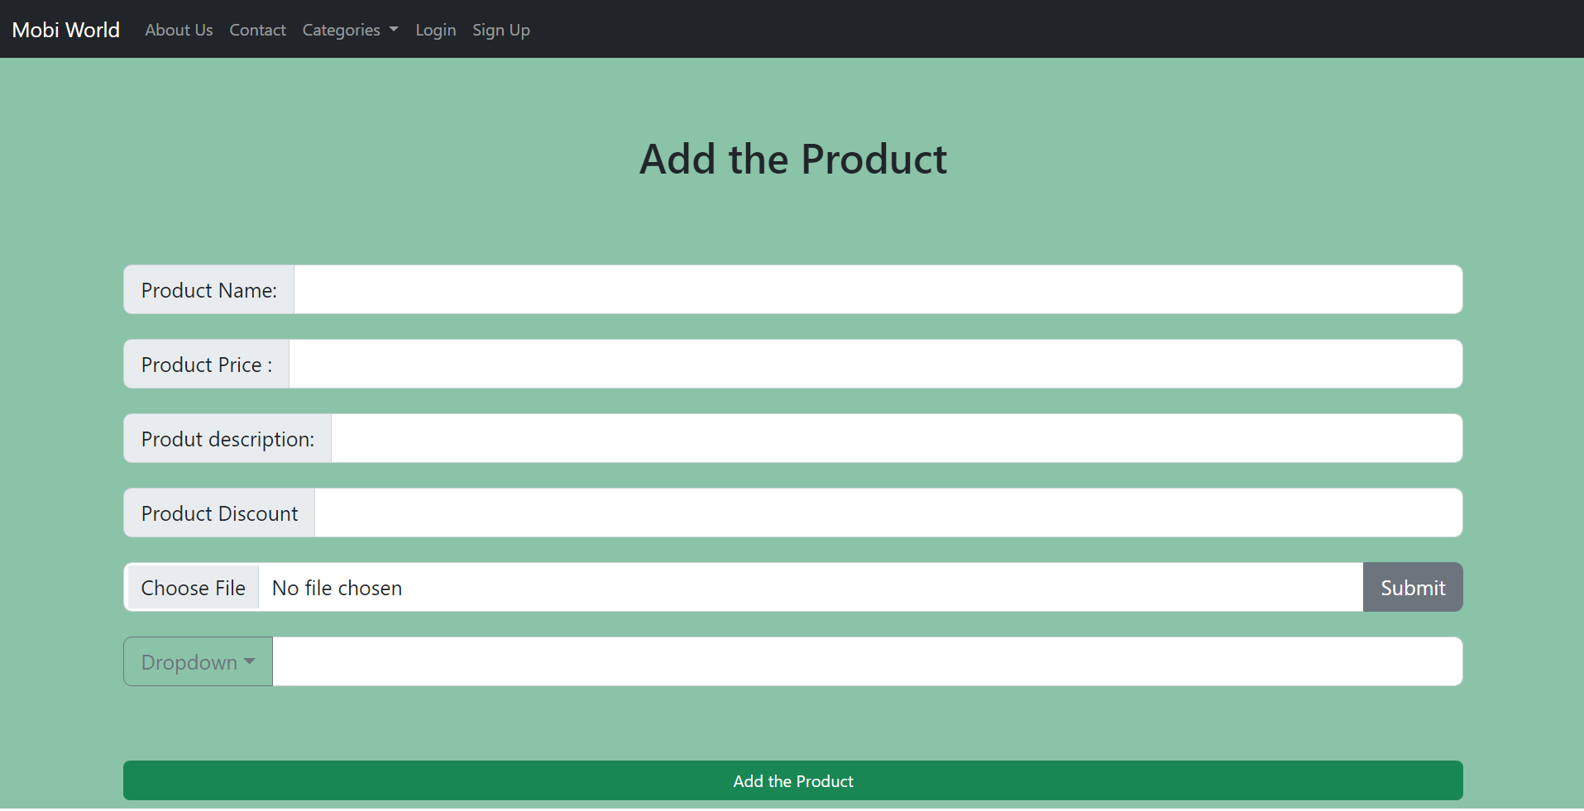

**Code Snippet:**

<!doctype html>

<html lang="en">

<head>

<meta charset="utf-8">

<meta name="viewport" content="width=device-width, initial-scale=1">

<title>Login :: Mobiworld</title>

<link href="https://cdn.jsdelivr.net/npm/bootstrap@5.2.0/dist/css/bootstrap.min.css" rel="stylesheet" integrity="sha384-gH2yIJqKdNHPEq0n4Mqa/HGKIhSkIHeL5AyhkYV8i59U5AR6csBvApHHNl/vI1Bx" crossorigin="anonymous">

</head>

<body>

<!--nav bar-->

<nav class="navbar navbar-expand-lg fixed-top navbar-dark bg-dark">

<div class="container-fluid">

<a class="navbar-brand" href="index.html">Mobi World</a>

<button class="navbar-toggler" type="button" data-bs-toggle="collapse" data-bs-target="#navbarNavAltMarkup" aria-controls="navbarNavAltMarkup" aria-expanded="false" aria-label="Toggle navigation">

<span class="navbar-toggler-icon"></span>

</button>

<div class="collapse navbar-collapse" id="navbarNavAltMarkup">

<div class="navbar-nav">

<a class="nav-link" href="#">About Us</a>

<a class="nav-link" href="#">Contact</a>

<li class="nav-item dropdown">

<a class="nav-link dropdown-toggle" href="#" role="button" data-bs-toggle="dropdown" aria-expanded="false"> Categories </a>

<ul class="dropdown-menu">

<li><a class="dropdown-item" href="#">Oppo</a></li>

<li><a class="dropdown-item" href="#">Vivo</a></li>

<li><a class="dropdown-item" href="#">Samsung</a></li>

<li><a class="dropdown-item" href="#">Iphone</a></li>

</ul>

</li>

<a class="nav-link" href="#">Login</a>

<a class="nav-link" href="#">Sign Up</a>

</div>

</div>

</div>

</nav>

<br><br>

<div class="bg-success p-2" style="--bs-bg-opacity: .5;">

<div class="container text-center">

<div class="row">

<div class="col align-self-center ">

<form action="" method="post" >

<h1 class="center"> Add the Product </h1>

<div class="input-group input-group-lg">

<span class="input-group-text" id="inputGroup-sizing-lg">Product Name:</span>

<input type="text" class="form-control" aria-label="Sizing example input" aria-describedby="inputGroup-sizing-lg">

</div> <br>

<div class="input-group input-group-lg">

<span class="input-group-text" id="inputGroup-sizing-lg">Product Price :</span>

<input type="text" class="form-control" aria-label="Sizing example input" aria-describedby="inputGroup-sizing-lg">

</div> <div class="input-group input-group-lg">

<span class="input-group-text" id="inputGroup-sizing-lg">Produt description:</span>

<input type="text" class="form-control" aria-label="Sizing example input" aria-describedby="inputGroup-sizing-lg">

</div>

<div class="input-group input-group-lg">

<span class="input-group-text" id="inputGroup-sizing-lg">Product Discount</span>

<input type="text" class="form-control" aria-label="Sizing example input" aria-describedby="inputGroup-sizing-lg">

</div>

<div class="input-group input-group-lg">

<input type="file" class="form-control" id="inputGroupFile04" aria-describedby="inputGroupFileAddon04" aria-label="Upload">

<button class="btn btn-secondary btn-alert" type="button" id="inputGroupFileAddon04">Submit</button>

</div>

<div class="input-group input-group-lg mb-3">

<button class="btn btn-outline-secondary dropdown-toggle" type="button" data-bs-toggle="dropdown" aria-expanded="false">Dropdown</button>

<ul class="dropdown-menu">

<li><a class="dropdown-item" href="#">oppo</a></li>

<li><a class="dropdown-item" href="#">Vivo</a></li>

<li><a class="dropdown-item" href="#">iphone</a></li>

</ul>

<input type="text" class="form-control" aria-label="Text input with dropdown button">

</div>

<div class="d-grid gap-2">

<button type="button" class="btn btn-success">Add the Product </button>

</div>

</form>

</div> </div> </div> </div>

<script src="https://cdn.jsdelivr.net/npm/bootstrap@5.2.0/dist/js/bootstrap.bundle.min.js" integrity="sha384-A3rJD856KowSb7dwlZdYEkO39Gagi7vIsF0jrRAoQmDKKtQBHUuLZ9AsSv4jD4Xa" crossorigin="anonymous"></script>

</body>

</html>